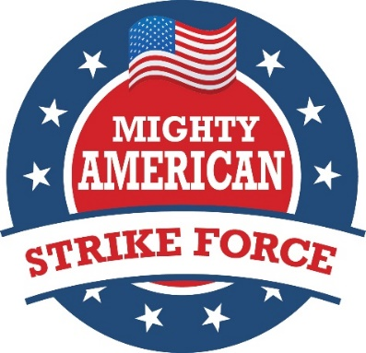

Founded in 1999 during Gov. George W. Bush’s first campaign for the presidency, The Mighty American Strike Force (MASF, formerly known as the Mighty Texas Strike Force) is a group of devoted volunteers who, at their own expense, agree to be deployed to national battleground swing states and critical Senate and House races during early voting the month before Election Day and also 7 to 10 days before General Election Day, to support Republican candidates. MASF volunteers provide key grass roots campaign support on the local level through block walking, rallies, social networking and phone bank operations.

In 2000, over 1200 volunteers and in 2004, over 2500 volunteers deployed with the Mighty American Strike Force to help George W. Bush win the presidency. Remnants of the group remained active in 2008. In 2012, with barely five weeks notice, over 600 Texans re-joined the Mighty American Strike Force and deployed to eight battleground states to campaign for the Romney/Ryan ticket and for all Republicans on the ballot in Ohio, Pennsylvania, Iowa, Nevada, Florida, Virginia, Colorado, and Wisconsin.

The Mighty American Strike Force is currently enlisting volunteers from across the nation to deploy to critical Senate and House races which will help the Republicans retain control of the Senate and House. The group is also targeting 13 presidential swing states to help the GOP put a conservative back in the White House.

Mighty American Strike Force
P.O. Box 5039
Austin, Texas 78763-5039
(512) 694-6848

www.mightyamericanstrikeforce.org email: info@mightyamericanstrikeforce.org

6/26/2016

