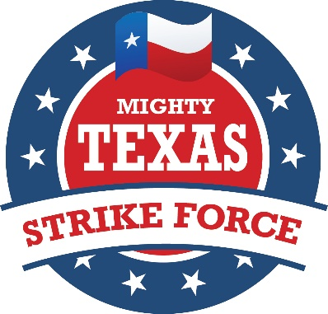

Founded in 1999 during Gov. George W. Bush’s first campaign for the presidency, The Mighty Texas Strike Force is a group of devoted Texas volunteers who, at their own expense, agree to be deployed to national battleground swing states or to targeted areas of our home State of Texas during early voting a month before Election Day and also 7 to 10 days before General Election Day, to support the Republican candidate for president and other candidates on the Republican ticket in the swing states and in targeted areas Texas. MTSF volunteers provide key grass roots campaign support on the local level through block walking, rallies, social networking and phone bank operations.

In 2004, over 2500 Texans deployed with the Mighty Texas Strike Force to help carry President George W. Bush to re-election. Remnants of the group remained active in 2008. In 2012, with barely five weeks notice, over 600 Texans re-joined the Mighty Texas Strike Force and deployed to eight battleground states to campaign for the Romney/Ryan ticket and for all Republicans on the ballot in Ohio, Pennsylvania, Iowa, Nevada, Florida, Virginia, Colorado, and Wisconsin.

The Mighty Texas Strike Force has expanded in 2016 to become the Mighty American Strike Force enlisting volunteers from across the nation to deploy to 13 targeted swing states to help the GOP put a conservative back in the White House to save our nation.
Mighty Texas Strike Force
P.O. Box 1822
Austin, Texas 78767
(512) 694-6848
www.mightytexasstrikeforce.com email: info@mightytexasstrikeforce.com
1/20/2016

